[Microsoft Azure AI Fundamentals AI-900](https://docs.microsoft.com/en-gb/learn/paths/get-started-with-artificial-intelligence-on-azure/)

**MODULES**

#### [Get started with AI on Azure](https://docs.microsoft.com/en-gb/learn/modules/get-started-ai-fundamentals/?WT.mc_id=cloudskillschallenge_65f698ca-417d-4883-898f-153f01d8236e&ns-enrollment-type=Collection&ns-enrollment-id=o1qrb71844dg)

#### [Use automated machine learning in Azure Machine Learning](https://docs.microsoft.com/en-gb/learn/modules/use-automated-machine-learning/?WT.mc_id=cloudskillschallenge_65f698ca-417d-4883-898f-153f01d8236e&ns-enrollment-type=Collection&ns-enrollment-id=o1qrb71844dg)

#### [Create a Regression Model with Azure Machine Learning designer](https://docs.microsoft.com/en-gb/learn/modules/create-regression-model-azure-machine-learning-designer/?WT.mc_id=cloudskillschallenge_65f698ca-417d-4883-898f-153f01d8236e&ns-enrollment-type=Collection&ns-enrollment-id=o1qrb71844dg)

#### [Create a Classification model with Azure Machine Learning designer](https://docs.microsoft.com/en-gb/learn/modules/create-classification-model-azure-machine-learning-designer/?WT.mc_id=cloudskillschallenge_65f698ca-417d-4883-898f-153f01d8236e&ns-enrollment-type=Collection&ns-enrollment-id=o1qrb71844dg)

#### [Create a Clustering Model with Azure Machine Learning designer](https://docs.microsoft.com/en-gb/learn/modules/create-clustering-model-azure-machine-learning-designer/?WT.mc_id=cloudskillschallenge_65f698ca-417d-4883-898f-153f01d8236e&ns-enrollment-type=Collection&ns-enrollment-id=o1qrb71844dg)

#### [Analyze images with the Computer Vision service](https://docs.microsoft.com/en-gb/learn/modules/analyze-images-computer-vision/?WT.mc_id=cloudskillschallenge_65f698ca-417d-4883-898f-153f01d8236e&ns-enrollment-type=Collection&ns-enrollment-id=o1qrb71844dg)

#### [Classify images with the Custom Vision service](https://docs.microsoft.com/en-gb/learn/modules/classify-images-custom-vision/?WT.mc_id=cloudskillschallenge_65f698ca-417d-4883-898f-153f01d8236e&ns-enrollment-type=Collection&ns-enrollment-id=o1qrb71844dg)

#### [Detect objects in images with the Custom Vision service](https://docs.microsoft.com/en-gb/learn/modules/detect-objects-images-custom-vision/?WT.mc_id=cloudskillschallenge_65f698ca-417d-4883-898f-153f01d8236e&ns-enrollment-type=Collection&ns-enrollment-id=o1qrb71844dg)

#### [Detect and analyze faces with the Face service](https://docs.microsoft.com/en-gb/learn/modules/detect-analyze-faces/?WT.mc_id=cloudskillschallenge_65f698ca-417d-4883-898f-153f01d8236e&ns-enrollment-type=Collection&ns-enrollment-id=o1qrb71844dg)

#### [Read text with the Computer Vision service](https://docs.microsoft.com/en-gb/learn/modules/read-text-computer-vision/?WT.mc_id=cloudskillschallenge_65f698ca-417d-4883-898f-153f01d8236e&ns-enrollment-type=Collection&ns-enrollment-id=o1qrb71844dg)

#### [Analyze receipts with the Form Recognizer service](https://docs.microsoft.com/en-gb/learn/modules/analyze-receipts-form-recognizer/?WT.mc_id=cloudskillschallenge_65f698ca-417d-4883-898f-153f01d8236e&ns-enrollment-type=Collection&ns-enrollment-id=o1qrb71844dg)

#### [Analyze text with the Language service](https://docs.microsoft.com/en-gb/learn/modules/analyze-text-with-text-analytics-service/?WT.mc_id=cloudskillschallenge_65f698ca-417d-4883-898f-153f01d8236e&ns-enrollment-type=Collection&ns-enrollment-id=o1qrb71844dg)

#### [Recognize and synthesize speech](https://docs.microsoft.com/en-gb/learn/modules/recognize-synthesize-speech/?WT.mc_id=cloudskillschallenge_65f698ca-417d-4883-898f-153f01d8236e&ns-enrollment-type=Collection&ns-enrollment-id=o1qrb71844dg)

#### [Translate text and speech](https://docs.microsoft.com/en-gb/learn/modules/translate-text-with-translation-service/?WT.mc_id=cloudskillschallenge_65f698ca-417d-4883-898f-153f01d8236e&ns-enrollment-type=Collection&ns-enrollment-id=o1qrb71844dg)

#### [Create a language model with Conversational Language Understanding](https://docs.microsoft.com/en-gb/learn/modules/create-language-model-with-language-understanding/?WT.mc_id=cloudskillschallenge_65f698ca-417d-4883-898f-153f01d8236e&ns-enrollment-type=Collection&ns-enrollment-id=o1qrb71844dg)

#### [Build a bot with the Language Service and Azure Bot Service](https://docs.microsoft.com/en-gb/learn/modules/build-faq-chatbot-qna-maker-azure-bot-service/?WT.mc_id=cloudskillschallenge_65f698ca-417d-4883-898f-153f01d8236e&ns-enrollment-type=Collection&ns-enrollment-id=o1qrb71844dg)

## **Exam Prep Videos: Microsoft AI-900**

Part 0: [AI Fundamentals Exam Prep Intro](https://www.youtube.com/watch?v=7DNOjwiCqXs&list=PLhpOApnq4S2joXwHfZjaK1yMjujZ6epLp&index=1&t=44s)

Part 1: [Describe Artificial Intelligence workloads and considerations](https://www.youtube.com/watch?v=hZQA77tu0t4&list=PLhpOApnq4S2joXwHfZjaK1yMjujZ6epLp&index=2) (15-20%)

Part 2: [Describe fundamental principles of machine learning on Azure](https://www.youtube.com/watch?v=eXdVbkEvOPw&list=PLhpOApnq4S2joXwHfZjaK1yMjujZ6epLp&index=3) (30-35%)

Part 3: [Describe features of computer vision workloads on Azure](https://www.youtube.com/watch?v=4EY7-M54sTo&list=PLhpOApnq4S2joXwHfZjaK1yMjujZ6epLp&index=4)  (15-20%)

Part 4: [Describe features of Natural Language Processing (NLP) workloads on Azure](https://www.youtube.com/watch?v=kR_qDu6i2h4&list=PLhpOApnq4S2joXwHfZjaK1yMjujZ6epLp&index=5)  (15-20%)

Part 5: [Identify conversational AI workloads](https://www.youtube.com/watch?v=AtW-5qElk5Q&list=PLhpOApnq4S2joXwHfZjaK1yMjujZ6epLp&index=6) of the Exam

[**Exam Prep Michelle’s Github Notes: Microsoft AI-900**](https://github.com/codess-aus/ai-fundamentals/tree/5539c5c8cf7ae9c29ca9e5b060307a7c8f30924e)

**Part 1: Describe ARTIFICIAL INTELLIGENCE workloads and considerations**

Time 60 - 90 min

40 - 60 Questions

Pass mark 700 / 1000 i.e.70%

Keywords

Historical USUALLY means REGRESSION

[AI Fundamentals Exam Prep Part 1](https://www.youtube.com/watch?v=hZQA77tu0t4&list=PLhpOApnq4S2joXwHfZjaK1yMjujZ6epLp&index=2)

Note: Anomaly Detection is ML, not AI

1. Prediction Forecasting
2. Conversational AI
3. Computer Vision
4. Natural Language Processing

**ARTIFICIAL INTELLIGENCE**  is software that imitates human capabilities

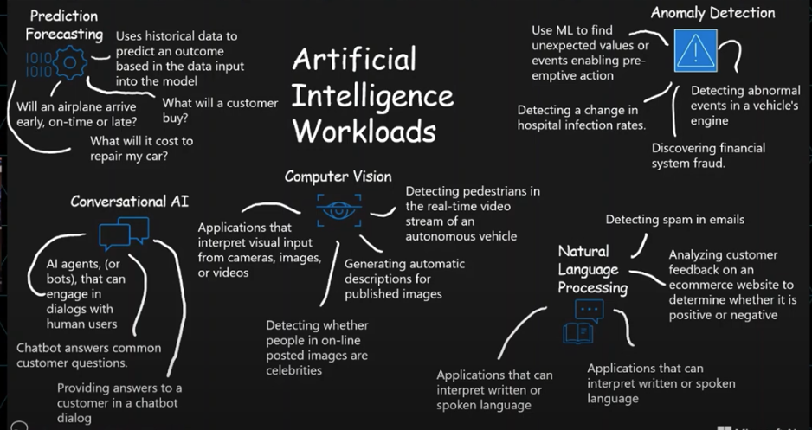

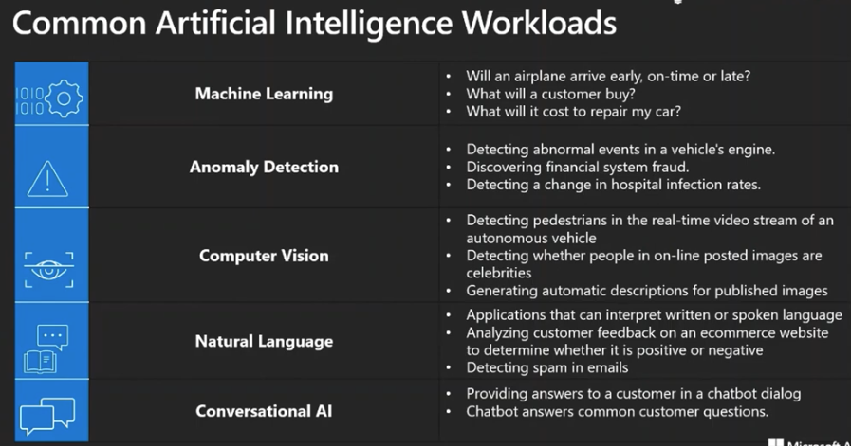

**MS Azure** is split into 3 components:



Azure Machine Learning Cognitive Services Azure Bot Services

Training, deploying managing Cognitive Services developers Cloud based service to

need to develop AI solutions develop and manage Bots

Mostly code free, drag and drop design studio or

**A. Prediction Forecasting in Microsoft Azure**

**Unsupervised Learning** - Labelled data is processed using an algorithm that finds relationships between features and labels. The results of the algorithm are encapsulated in a model.

**Anomaly Detection:** telemetry data is collected (i.e. via sensors etc.)

An Anomaly detection model is trained to understand the expected fluctuation in the data over time.

If a measure is outside the normal expected range, the model reports the anomaly.

eg. Car Racing - Brake temperature, engine revolutions. Driver can be called in for a pit stop before the vehicle is completely immobilised.

**Computer Vision Models and capabilities (6 Categories)**

**Image Classification** - Training a ML Model to identify images based on their content - taxi, bus, cycle.

**Object Detection** - Training a ML Model to classify individual objects in an image and identify their location with a bounding box.

**Semantic Segmentation** - (Advanced Machine Learning) Individual pixels in an image are classified according to the object to which they belong.

e.g. Traffic Monitoring Solution - overlay traffic images with mask layers to highlight different types of vehicles using specific colours - Red - Bus, blue - Car, green - Cyclist

e.g. Self Driving cars - identify objects to the pixel, not a bounding box that includes other things on the background.

**COMBINED ML SOLUTION -** You can create solution that combine Machine Learning Models with Advanced Image analytics techniques to extract information from images, including tags, help catalogue the image or descriptive captions that summarise the scene shown in the image.

e.g.‘Seeing AI’ - for the Vision impaired - real world environment to audio via a smartphone.

**Face Detection** - Specialised form of object detection that locates human faces in an image. It can be combined with Classification and Facial Geometry Analysis techniques to infer details such as age, emotional state and even recognise individuals.

*Has the greatest capacity to do good or be used for evil*

Needs lots of data, good data, from a variety of background etc.

**Optical Character Recognition (OCR)** - Identified text in an image and translate it to text

eg. Image of Whiteboard full of Lectures notes, converted to a Word doc.

**B. Conversational AI in Microsoft Azure**

* Speech
* Search
* Languange Understanding
* Qand A Maker
* Vision

**Azure Bot Service:**

A platform for creating, publishing and managing and deploying Bots.

Developers can use the Bots framework to create a bot and manage it with Azure Bot Services

Integrate other backend services like Q and A maker, LUIS (Language Understanding Intelligent Service)

Connect to channels (use the bot on different comms medium) - Web Chat, email, Microsoft Teams, etc.

**C. Computer Vision in Microsoft Azure**

**D. Natural Language Processing in Microsoft Azure**

**Practice Questions:**

| **Scenario** | **An example of:** |
| --- | --- |
| Predicting if an aeroplane arrives early, on time or late. | Forecasting AI Workload |
| Detecting the language in text. | Language Processing AI Workload |
| Detecting Pedestrians in real time video stream of an autonomous vehicle | Computer Vision AI Workload |
| Providing answers to a customer in a chatbot dialogue | Conversational AI Workload  Bot Service |

| Detecting whether people in online posted images are celebrities | Computer Vision AI Workload |
| --- | --- |
| Predicting whether a customer would buy certain items based on their purchase history | Forecasting AI Workload |
| Using Graphics and menus to improve the user experience with an ecommerce website chatbot | NONE, but relates to  Conversational AI Workload  Bot Service (distraction answer) |
| Analysing customer feedback on an ecommerce website to determine whether it is positive or negative | Natural Language Workload -  Sentiment analysis |

| Forecasting who will win the race | Prediction |
| --- | --- |
| using the power of AI to help deeply understand and explore vast amounts of information to get better insights and uncover hidden relationships and patterns of the data. | Knowledge Mining |
| The process of using machine learning to monitor and detect unexpected items or events in time series data that differ from the norm | Anomaly Detection |

For which of these scenarios would you use an AI Based Prediction Solution

| Detecting abnormal events in a vehicle's engine | Anomaly Detection - (real time) |
| --- | --- |
| Detecting the speed limit using road side signage | Computer Vision - OCR |
| Determining the distance to the vehicle in front | Computer Vision - Detect Objects in 2D images and video streams and the distance to these objects can then be calculated |
| Determining the likely repair costs for an accident involving a vehicle | AI Based Prediction Solution -  YES  The machine learning model finds patterns in the provided information, such as the amount of damage, the location of the damage, the parts damaged, and this is compared to historical data of previous collisions and repairs. It can then predict the amount of time required to repair the damage and the cost of the parts. |

| Translating commands into actions (“turn off the lights”) | Language Processing AI Workload |
| --- | --- |
| Determining abnormalities in health scans | Computer Vision |
| Finding relevant information to answer a specific customer question | Conversational AI and Language Processing AI Workloads |
| Discover financial system fraud. | Anomaly Detection |

| Making a travel reservation | Conversational AI and Natural Language Processing (Speech Services) AI Workloads |
| --- | --- |
| Detecting spam in emails | Natural Language Processing |
| Detecting a change in hospital infection rates | Anomaly Detection |
| Translating speech from one language to another | Natural Language Processing - Language Translation |
| Answering frequently asked questions | Conversational AI |

**Ai Agents** (Bots - Conversational AI)) engage in conversations with human users. Bots use natural language processing to make sense of human input and identify the actions a human wants to perform. It also identifies the object that the action is being performed on. Bots can perform. They can also prompt the human for a information required to complete a transaction

Common uses include:

Making Travel arrangements

Responding to human questions with answers from a Knowledge base.

**Conversation AI with Natural Language Processing (**NLP) can find the most appropriate answers from the Qand A pairs. This provides the answer back to the human.

## **Categories of Cognitive Services**

**Cognitive Services** can be categorised into four main pillars:

* Vision
* Speech
* Language Processing
* Decision

## **Vision APIs**

| **Service Name** | **Service Description** |
| --- | --- |
| [Computer Vision](https://docs.microsoft.com/en-us/azure/cognitive-services/computer-vision/) | The Computer Vision service provides you with access to advanced cognitive algorithms for processing images and returning information. |
| [Custom Vision](https://docs.microsoft.com/en-us/azure/cognitive-services/custom-vision-service/) | The Custom Vision Service lets you build, deploy, and improve your own image classifiers. An image classifier is an AI service that applies labels to images, based on their visual characteristics. |
| [Face](https://docs.microsoft.com/en-us/azure/cognitive-services/face/) | The Face service provides access to advanced face algorithms, enabling face attribute detection and recognition. |
| Forms | Form Recognition Service - recognise different receipts etc and select required data for appropriate field. |

## 

## 

## 

## **Speech APIs**

| **Service Name** | **Service Description** |
| --- | --- |
| [Speech service](https://docs.microsoft.com/en-us/azure/cognitive-services/speech-service/) | Speech service adds speech-enabled features to applications. Speech service includes various capabilities like speech-to-text, text-to-speech, speech translation, and many more. |

## **Language APIs**

| **Service Name** | **Service Description** |
| --- | --- |
| [Language service](https://docs.microsoft.com/en-us/azure/cognitive-services/language-service/) | Azure Language service provides several Natural Language Processing (NLP) features to understand and analyse text. |
| [Translator](https://docs.microsoft.com/en-us/azure/cognitive-services/translator/) | Translator provides machine-based text translation in near real time. |
| [Language Understanding LUIS](https://docs.microsoft.com/en-us/azure/cognitive-services/luis/) | **Language Understanding Intelligent Service (LUIS)** is a cloud-based conversational AI service that applies custom machine-learning intelligence to a user's conversational or natural language text to predict overall meaning and pull out relevant information. |
| [QnA Maker](https://docs.microsoft.com/en-us/azure/cognitive-services/qnamaker/) | QnA Maker allows you to build a question and answer service from your semi-structured content. |

## **Decision APIs**

| **Service Name** | **Service Description** |
| --- | --- |
| [Anomaly Detector](https://docs.microsoft.com/en-us/azure/cognitive-services/anomaly-detector/) | Anomaly Detector allows you to monitor and detect abnormalities in your time series data. |
| [Content Moderator](https://docs.microsoft.com/en-us/azure/cognitive-services/content-moderator/overview) | Content Moderator provides monitoring for possible offensive, undesirable, and risky content. |
| [Personalizer](https://docs.microsoft.com/en-us/azure/cognitive-services/personalizer/) | Personalizer allows you to choose the best experience to show to your users, learning from their real-time behavior. |

## 

## **Responsible AI**

**Fairness** AI systems should treat all people fairly Eliminate Bias

**Reliability & Safety** AI systems should perform reliably and safely Testing / Management

**Privacy & Security** AI systems should be secure and respect privacy Protect /

**Inclusiveness** AI systems should empower everyone and engage people Benefits all parts of society

**Transparency** AI systems should be understandable Communication / Explanations

(Purpose, How, Limitations)

**Accountability** People should be accountable for AI systems Meet ethical and legal standards

**Part 2:** [**Describe fundamental PRINCIPLES OF MACHINE LEARNING on Azure**](https://github.com/codess-aus/ai-fundamentals#fundamental-principles-of-machine-learning-on-Azure)

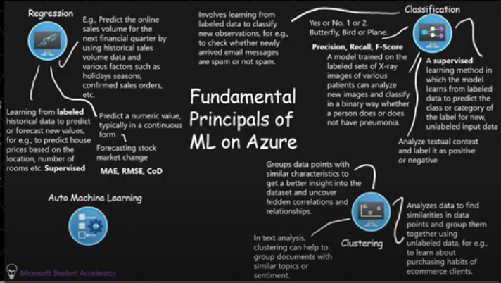

**Machine Learning -** Creating predictive models by find relationships in data

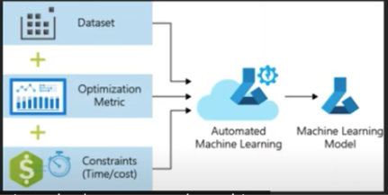

**Azure Machine Learning** is a cloud based machine learning platform

**Automated Machine Learning** - (Regression and Classification) Supply the data to the desired model type and let Azure Machine Learning find the best model

NOTE: Always select **Explain Best Model** option - (Transparency) Allows you to understand why the model was selected, How the model works and enables you to meet regulatory requirements and provide transparency to users.

**Azure machine Learning Designer** - Visual tool for creating Machine Learning Pipelines

**Supervised** (Labelled Data)

* **Regression**
  + [Absolute-loss](https://en.wikipedia.org/wiki/Mean_absolute_error) or Mean absolute error (**MAE**) - The closer to 0.00, the better
  + [RMS-loss](https://en.wikipedia.org/wiki/Root-mean-square_deviation) or Root Mean Squared Error (**RMSE**) (also called Root Mean Square Deviation, RMSD) - The closer to 0.00, the better
  + [Squared-loss](https://en.wikipedia.org/wiki/Mean_squared_error) or Mean Squared Error (MSE), also called Mean Squared Deviation (MSD) - The closer to 0.00, the better
  + [R-squared (R2)](https://en.wikipedia.org/wiki/Coefficient_of_determination) or Coefficient of determination - The closer to 1.00, the better
  + [Absolute-loss](https://en.wikipedia.org/wiki/Mean_absolute_error) or Mean absolute error (MAE) - The closer to 0.00, the better
* **Classification - Binary**
  + Recall - True Positive / True Positive + False Negative
  + Precision - True Positive / True Positive + False Positive
  + [F1 score](https://en.wikipedia.org/wiki/F1_score) - The closer to 1.00, the better
  + [Accuracy](https://en.wikipedia.org/wiki/Accuracy_and_precision#In_binary_classification) - The closer to 1.00, the better, but not = 1
  + AUC / [aucROC](https://en.wikipedia.org/wiki/Receiver_operating_characteristic) - The closer to 1.00, the better
  + AUCPRThe closer to 1.00, the better
* **Classification - Multi Class**
  + [Micro-average Accuracy](https://docs.microsoft.com/en-us/dotnet/api/microsoft.ml.data.multiclassclassificationmetrics.microaccuracy#microsoft-ml-data-multiclassclassificationmetrics-microaccuracy) - The closer to 1.00, the better
  + [Macro-average Accuracy](https://docs.microsoft.com/en-us/dotnet/api/microsoft.ml.data.multiclassclassificationmetrics.macroaccuracy#microsoft-ml-data-multiclassclassificationmetrics-macroaccuracy) - The closer to 1.00, the better
  + **Log-loss -** The closer to 0.00, the better
  + [Logarithmic loss reduction](https://docs.microsoft.com/en-us/dotnet/api/microsoft.ml.data.multiclassclassificationmetrics.loglossreduction#microsoft-ml-data-multiclassclassificationmetrics-loglossreduction) - 0.20, = the probability of a correct prediction is 20% better than random guessing

**Unsupervised**

* **Clustering**
  + NONE - clustering analysis doesn’t have a solid evaluation metric, There is no right answer

**Reinforcement Learning** - Action / Reward / Strategy

## **An Azure Machine Learning Designer Pipeline**

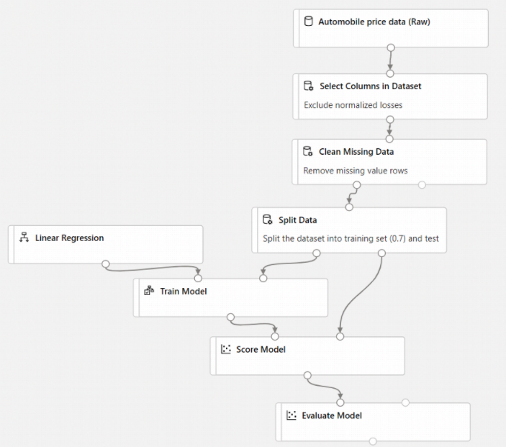

### 

### 

**Part 3:** [**Describe features of COMPUTER VISION workloads on Azure**](https://github.com/codess-aus/ai-fundamentals#features-of-computer-vision-workloads-on-azure)

### 

**An image** is just an array of pixel values.The values can be used as features to train Machine Learning Model that can make **predictions** about the image and its contents. (Predicting where the text is, predicting segments, predicting text etc.

Predictions are always associated with a degree of confidence - it is never 100% definite, unlike humans.

**Semantic** **Segmentaion** - Boxed major components of an image - Bus, Car, Person, etc.

Evaluate whether two faces belong to the same person Verify

Extract faces that look alike from a list of faces Find Similar

Divide a set of faces based on similarities Group

??? Identify

**Part 4:** [**Describe features of NATURAL LANGUAGE PROCESSING (NLP) workloads on Azure**](https://github.com/codess-aus/ai-fundamentals#features-of-nlp-workloads-on-azure)

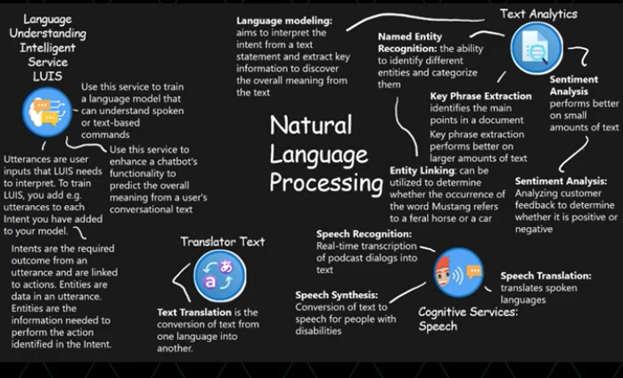

**Part 5:** [**Identify conversational AI workloads**](https://github.com/codess-aus/ai-fundamentals/blob/5539c5c8cf7ae9c29ca9e5b060307a7c8f30924e/Workloads.md#5-identify-conversational-ai-workloads)

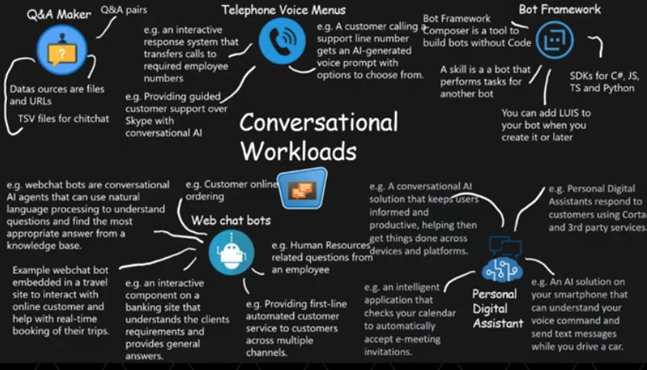

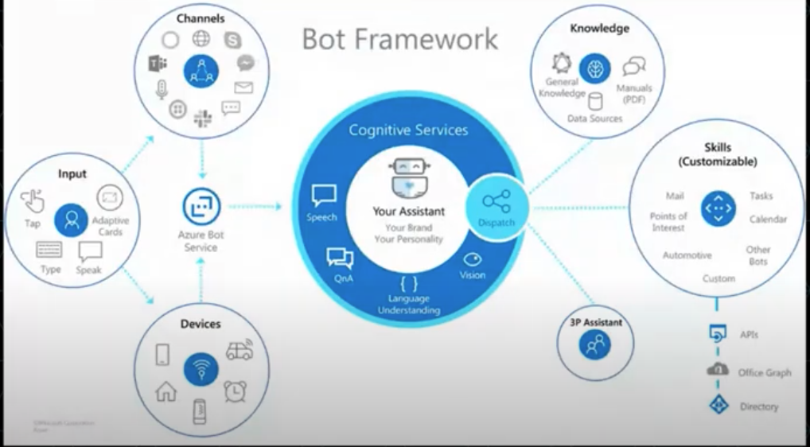

**Conversational AI** is a solution that enables a dialog between an AI agent and a human, knowns as Chat **Bots**.

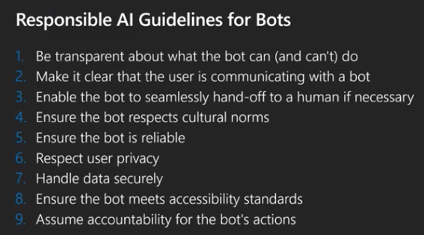

### **Keywords**

Historical / History USUALLY means REGRESSION

Predict / Forecast USUALLY means REGRESSION

Prediction / Predicting = Forecasting AI Workload

Patterns - Anomaly Detection

Classification - Category

Clustering - grouping

Image Prediction = Object detection

**Next is AI-100 (Associate)**